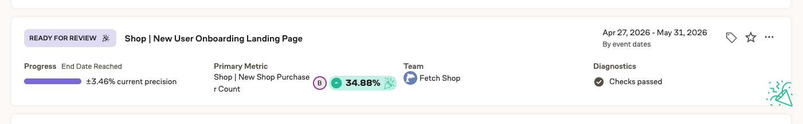

Case study style
https://www.halo-lab.com/project/ahlya

FETCH SHOP / PRODUCT DESIGN CASE STUDY

From scanning receipts
to a first Shop purchase
Designing onboarding that helps users understand, try and trust a new way to earn.
Natalie Peterson | Product design, Fetch Shop
Scope: experience strategy, research synthesis, interaction design, interface design and flow documentation
Testing: five participants | 4.4/5 reported motivation for a 4,000-point Welcome Bonus [3]

01 Overview
Fetch had an established behavior: shop, submit a receipt and earn points. Fetch Shop asked users to start differently: open Fetch before an online purchase, then check out with the retailer. The challenge was to make that change feel like a simple extension of familiar shopping habits, rather than another rewards experience to learn.
I designed a new-user experience inside the Shop page that brought together a short explanation of the model, familiar retailers, a first-purchase Welcome Quest and visible progress through the purchase-and-rewards flow. The goal was to turn initial curiosity into a first eligible Shop purchase while setting expectations about what would happen afterward. [1, 2]
The strategic shift: from presenting everything Shop offers to making the next useful action obvious.

02 Problem statement
The existing experience asked users to choose a shopping opportunity before they understood how Shop worked. Some interpreted Shop as a place to redeem points. Others struggled to distinguish it from receipt-based earning or understand why they needed to begin their shopping journey in Fetch. A dense mix of retailers, products and point values made that learning harder. [1]
The confusion continued after checkout. Users often did not expect points to remain pending or know where to find them. The project brief described a 3-90-day arrival window, making expectation-setting part of the activation problem, not just a support concern. [1, 2]
This was not a redesign of receipt submission or gift-card redemption. Those familiar experiences shaped the mental model we needed to bridge. The business challenge was the path from viewing Shop to selecting a retailer, visiting that retailer and completing a first confirmed purchase. [1]
How might we help someone who knows Fetch as a post-purchase rewards app confidently make their first Shop purchase, without overwhelming them or overpromising rewards?

03 Research
I built on existing research rather than treating discovery as a final check on a finished design. The foundation included the UX Research team's June 2025 activation study: unmoderated tasks with 16 participants, split between people new to Fetch and existing eReceipt users new to Shop. The study also synthesized Marketing's research on exploration, non-conversion and pending points. [1]
That distinction between audiences mattered. Someone familiar with Fetch needed to understand a new earning method; someone entirely new needed help understanding both Fetch and Shop. One generic onboarding experience would not address those needs equally well.
19% of surveyed engaged non-converters said they needed a better understanding of how Shop worked. This was a comprehension barrier, not simply a discovery problem. [1]
Research insight | Design implication
Some users confused Shop with redemption, and most study participants skipped the introductory video. | Put a concise explanation on the Shop page, where users make their first decision, rather than relying on a separate tutorial.
Familiar retailer names drew attention before point values. | Use receipt history to surface relevant stores, with popular-store defaults when history is insufficient.
High-value flat bonuses were more compelling than points-per-dollar rates alone. | Give the first purchase a concrete incentive through the Welcome Quest, while still explaining ongoing earning.
Unexpected pending points undermined confidence. | Treat confirmation, pending progress and reward completion as part of onboarding, not as an unrelated post-purchase experience.

Research findings: Shop Activation Research, June 2025, slides 9-15. Design responses: supplied onboarding screens and user flows. [1, 2]

Turning research into a focused strategy
The research prioritized clarity, a worthwhile effort-to-reward ratio and a trustworthy rewards flow, followed by prompting and discovery. I translated those needs into a focused experience: explain the model, surface a familiar retailer, provide a compelling flat-point bonus, make the purchase path simple and set clear tracking expectations. [1]
The data-informed work was not limited to reporting a funnel. Purchase history became a personalization input; missing history required explicit fallback rules; and a retailer visit had to remain distinct from a confirmed purchase. These distinctions shaped both the interface and how success should be evaluated.

03 Research

Testing the First Purchase Quest
An evaluative study of the onboarding experience included five U.S. participants. The reported average motivation to complete onboarding for a 4,000-point Welcome Bonus was 4.4 out of 5. Reception was positive, driven primarily by the bonus, with strong appreciation for the game-like progress indicator. [3]
"I really like how there's a bar that fills in... it kind of gives you that feeling when you’re playing a game."
Participant quote reported in the First Purchase Quest testing brief. [3]
What testing revealed [3] | Implication for the next iteration
The three-step progress bar was the most praised element, but one participant was confused by "Tap Store." | Retain visible progression; make the first action and its destination more explicit.
Comparisons with Rakuten and Honey provided a familiar reference, but users questioned whether shopping stayed in Fetch's browser or opened a retailer app, and whether points would track. | Explain the actual retailer handoff and relevant earning requirements before users leave Fetch.
Users were unsure whether Shop replaced or supplemented receipt scanning. | Clarify the relationship between earning methods and any receipt steps, using confirmed eligibility rules.
"We’re checking with the store" and estimated timing were appreciated, although some considered waits of 7+ days long. | Keep status visibility and realistic timing; do not confuse clearer expectations with faster point delivery.
One participant struggled with small UI text; the cancellation mascot was also described as discouraging. | Improve status readability and test more neutral, supportive cancellation language and imagery.

What the study supported
The study provided qualitative support for the Quest and visible progress, while identifying unresolved comprehension issues. The motivation score reflects the combined incentivized concept, not observed purchase conversion or the isolated effect of the interface. [3]
Requests for categories, alphabetical browsing and prominent frequently visited stores also surfaced. I would prioritize earning-model clarity, handoff guidance and readable status first, then validate broader discovery changes. [3]

04 Ideation

An onboarding system, not a tutorial
I approached onboarding as a set of user and transaction states rather than a sequence of instructions to dismiss. The experience needed to account for existing Fetch users, entirely new users, people who visited a retailer without buying, purchases awaiting confirmation and orders that were canceled or returned.
The architecture centered on three reusable elements: an educational header, retailer shelves and a stateful Quest card. For users with enough receipt history, the first retailer choices could reflect stores they already used. For users without that history, popular retailers provided a useful starting point without pretending to be personalized. [2]
The user-flow documentation extended beyond the successful purchase path to pending rewards and cancellation or return scenarios. This made the design less dependent on an idealized journey and clarified where messages should change as the user progressed. [2]
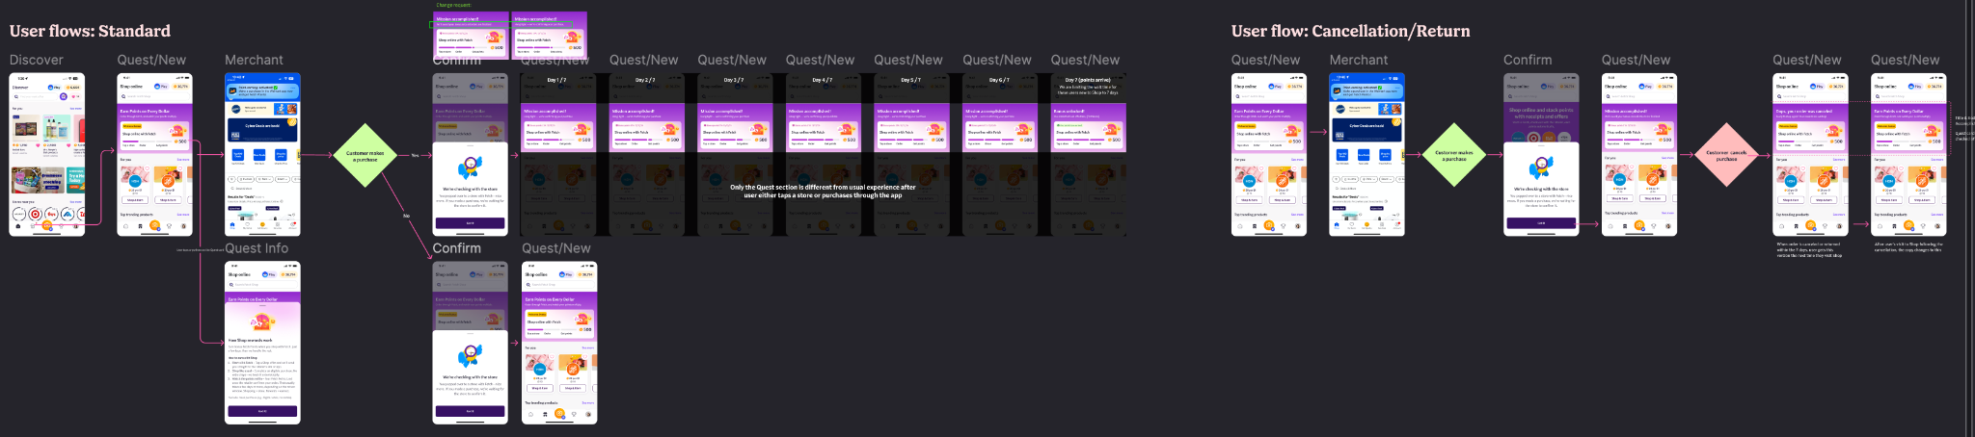
Figure 1. The flow board maps the standard journey alongside cancellation and return states, extending the experience beyond an idealized purchase path. [2]

Prioritizing the first meaningful behavior
I kept the concept centered on what a first-time shopper needed to understand and do. Broader discovery, search, checkout and navigation opportunities remained part of the larger Shop problem space, but they did not all need to be solved in this onboarding experience. The organizing question was whether a change helped users take the next step toward a first eligible purchase.

AI-supported exploration, human-owned design decisions
Across my Shop work, I used AI to organize ideas, pressure-test explanations, explore copy alternatives and sharpen experiment hypotheses. This supported iteration around the design problem without replacing the research or the judgment needed to prioritize the experience.
The design-to-engineering story is visible in the annotated artifacts: audience rules, retailer fallbacks, state changes and return paths were documented alongside the screens. Visual hierarchy, reward language and the meaning of each progress state still required deliberate review. AI-generated suggestions were inputs, not evidence that a concept would improve conversion.

05 Solution

Make the first decision easier
The redesigned entry experience was organized around four questions: what Shop is, how to earn, where to start and why it is worth trying. The header positioned Shop alongside receipts and eligible offers, with the intended sequence of starting in Fetch and checking out with the retailer. Testing showed that the relationship between those earning methods still needed clarification. [2, 3]
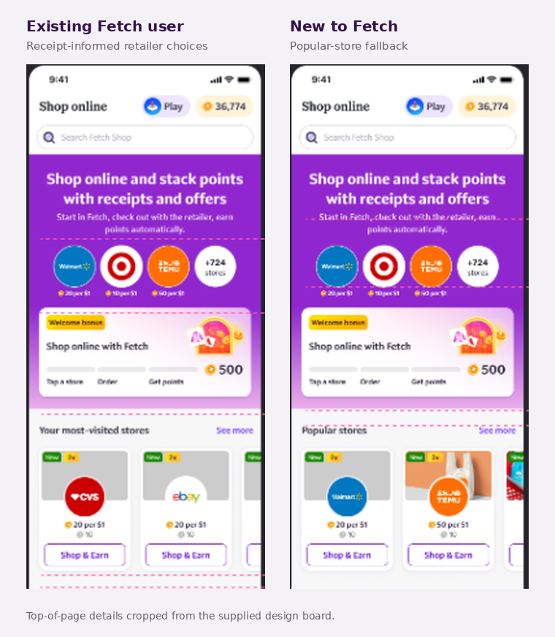
Figure 2. Receipt-informed retailer choices for existing Fetch users; popular-store defaults for new users. Shown: a 500-point Quest. The evaluative study used a 4,000-point Welcome Bonus. [2, 3]
Familiar retailers sat close to the explanation, turning an abstract value proposition into an immediate action. Lower shelves continued that logic: frequently visited stores where history existed, popular stores where it did not, and rules to avoid repeating the same retailers unnecessarily. [2]
The Quest paired the steps "Tap a store," "Order" and "Get points" with a concrete reward. The supplied screens show 500 points; the study assessed a 4,000-point Welcome Bonus. Participants praised the progress bar, but that motivation result should not be generalized to the 500-point design. [2, 3]

05 Solution

Explain more when needed; stay present afterward
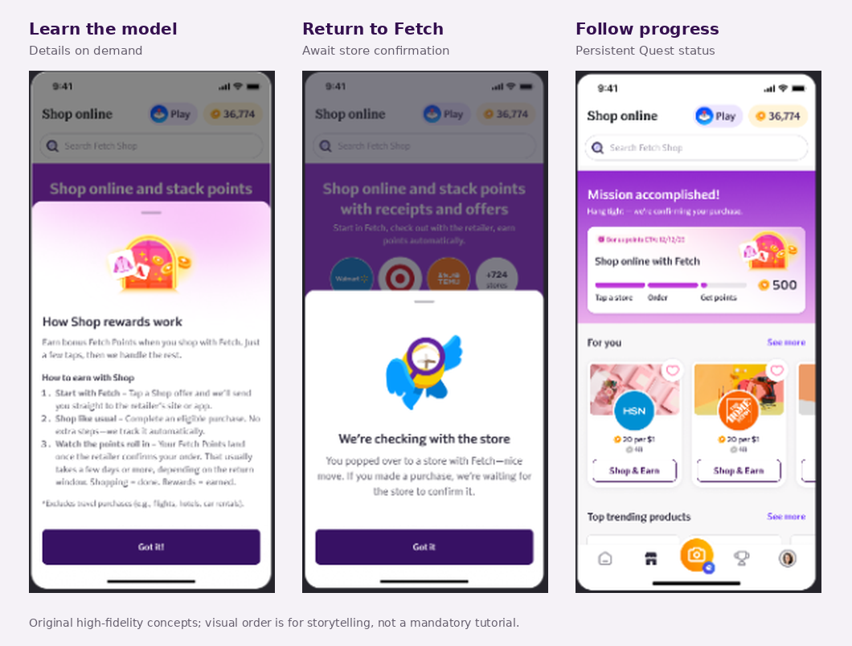
Figure 3. Optional education, conditional reassurance after a retailer visit, and persistent Quest status. These concepts show different moments in the experience, not proof of a completed purchase or an immediately available reward.
Tapping the Quest opened "How Shop rewards work," with additional explanation of the retailer handoff, eligible purchase and store-confirmation process. Keeping that detail available on demand avoided making every shopper complete a separate tutorial before starting. [2]
On return to Fetch, "We're checking with the store" acknowledged the visit without claiming an order had been confirmed. Its conditional wording - "If you made a purchase" - mattered: the documented trigger was a first retailer visit lasting at least two minutes, which indicated engagement, not proof of purchase. [2]

The scope tradeoff: clearer status, not a new tracking system
I concentrated the design changes in the landing-page header, Quest component and bottom-sheet pattern rather than rebuilding retailer checkout or promising instant confirmation. After initial engagement, most of the page returned to the standard Shop experience while the Quest region continued to communicate progress. [2]
This contained scope improved the explanation of the existing process without shortening retailer confirmation times. Testing supported the reassurance value of status and estimated timing, while exposing unresolved handoff questions. Clearer communication and deeper tracking improvements therefore remained distinct opportunities. [3]

06 Impact

Early evidence of motivation, with specific friction to resolve
The First Purchase Quest evaluation produced a reported average motivation score of 4.4/5 across five participants for the 4,000-point Welcome Bonus. Participants responded positively to the incentive and progress visualization, including a sense of accomplishment after a simulated purchase. [3]
This was a qualitative concept-evaluation result, not a satisfaction score, task-completion rate or measured lift in purchases. It supported continuing to refine the experience while making the remaining comprehension and usability gaps explicit. [3]
Evidence | What the evaluation supports [3]
Stated motivation | 4.4/5 reported average for onboarding with a 4,000-point Welcome Bonus; five participants.
Progress and momentum | Participants praised the three-step visualization and the feeling of progress after a simulated purchase.
Status transparency | Pending messages and estimated timing were appreciated; some still considered the waiting period long.
Remaining friction | Retailer handoff, receipt-scanning expectations, small text, cancellation tone and store-discovery requests.

From research signals to business outcomes
To establish launch impact, I would measure first confirmed eligible purchases among new Shop users exposed to the experience, with merchant engagement as a leading indicator. Repeat purchasing after the welcome incentive and tracking-related support contacts would help assess whether activation translated into sustained value.
To separate interface improvements from incentive effects, I would compare onboarding variants at a fixed bonus amount, then evaluate bonus size separately. Purchase and repeat-usage windows would need to allow for retailer confirmation and pending rewards. These experiments would test behavior beyond the stated motivation captured in research.

Why this matters to Fetch
The intended business value was a larger share of shopping initiated and attributed through Fetch, creating more opportunities to connect partner purchases with rewards. In a data-for-rewards model, that makes a first Shop purchase more meaningful than a page visit. Sustained repeat purchasing would be stronger evidence of value than a short-term engagement spike.
The business question is not simply whether users tap more stores. It is whether more new users complete an eligible purchase, receive the expected rewards and choose to shop through Fetch again after the welcome incentive.

07 Learnings

Motivation is not the same as comprehension
Participants were eager to earn the welcome bonus while still questioning the retailer handoff and receipt requirements. I would not treat a high motivation score as proof that users understood the flow. The next iteration must make earning requirements clearer, not assume that a larger reward resolves confusion. [3]

Progress explains the journey, not necessarily every action
The game-like progress bar resonated, yet one participant still questioned "Tap Store." That distinction matters: a sequence can feel encouraging without making its first action self-explanatory. I would preserve the progress pattern and test more explicit action labels and handoff guidance. [3]

Precision and tone are part of trust
Participants appreciated pending-point transparency, but some disliked the wait. One cancellation visual felt discouraging, and small text created a readability issue for one participant. These findings point to a next iteration that pairs clear status with readable details and supportive language, without implying points are available before they are awarded. [3]

What I would test next
Question | Next test
Can users explain the handoff and receipt requirements? | Test explicit transition and earning-model copy; ask users where they will shop and which receipt steps, if any, remain.
Is reward status readable and unambiguous? | Test larger status text, milestone-specific wording and a neutral cancellation state; check pending versus awarded understanding.
Does clearer onboarding change purchase behavior? | Compare onboarding variants with the bonus held constant, then evaluate incentive size separately using confirmed purchases and repeat usage.

I would begin with short, task-based usability rounds, then move to controlled experiments segmented by prior Fetch experience. The decision criteria would include comprehension, first confirmed purchases, repeat usage and tracking confusion, rather than motivation ratings or card taps alone.
The test showed motivation. The next iteration must show that users can confidently act on it.

Sources
[1] Jen Luong and Julie Froelich, Shop Activation Research, June 2025. Methods: slide 3. Findings: slides 9-15. Priorities and success signals: slides 24 and 28.
[2] Project artifacts: Overview slide; Standard and Cancellation/Return user-flow board; New Screen Versions design board. Screens show a 500-point Quest.
[3] UX Research Brief: Testing a New Fetch Shop Onboarding Experience (First Purchase Quest). Five participants; 4,000-point Welcome Bonus; 4.4/5 reported motivation. Findings and participant quotations from the supplied brief.

